NUMBER OF ISLANDS

24ITC32 - ADVANCED DATA STRUCTURES

MINI PROJECT REPORT
Submitted by

AAKASH RAAM P
(24ITR002)
HARSHAD V
(24ITR047)
JEEVAN PRASATH P
(24ITR053)

in partial fulfilment of the requirements for the award of the degree of

BACHELOR OF TECHNOLOGY IN
INFORMATION TECHNOLOGY
DEPARTMENT OF INFORMATION TECHNOLOGY


KONGU ENGINEERING COLLEGE
(AUTONOMOUS)
PERUNDURAI, ERODE – 638 060
NOVEMBER 2025
DEPARTMENT OF INFORMATION TECHNOLOGY KONGU ENGINEERING COLLEGE (AUTONOMOUS)
PERUNDURAI, ERODE – 638 060
NOVEMBER 2025
BONAFIDE CERTIFICATE

This is to certify that the Project Report titled NUMBER OF ISLANDS is the bonafide record of project work done by AAKASH RAAM P (24ITR002), HARSHAD V (24ITR047), JEEVAN PRASATH (24ITR053) in partial fulfillment of the requirements for the award of the Degree of Bachelor of Technology in INFORMATION TECHNOLOGY of Anna University, Chennai during the year 2025 - 2026

Submitted for the end semester viva voce examination held on

COURSE FACULTY HEAD OF THE DEPARTMENT
(Signature with seal)

ii
DEPARTMENT OF INFORMATION TECHNOLOGY KONGU ENGINEERING COLLEGE (AUTONOMOUS)
PERUNDURAI, ERODE – 638 060
NOVEMBER 2025
DECLARATION

We affirm that the Project Report titled NUMBER OF ISLANDS being submitted in partial fulfillment of the requirements for the award of Bachelor of Technology is the original work carried out by us. It has not formed part of any other project report or dissertation based on which a degree or award was conferred on an earlier occasion on this or any other candidate.

AAKASH RAAM P
24ITR002

HARSHAD V
24ITR047

JEEVAN PRASATH P
24ITR053

I certify that the declaration made by the above candidates is true to the best of my knowledge

Date: Name and Signature of the course faculty with seal

iii
ABSTRACT

This project titled NUMBER OF ISLANDS focuses on identifying distinct connected land regions within a two-dimensional grid that represents a map of land and water. Implemented in Java, the system applies Depth-First Search (DFS), a fundamental graph traversal technique, to efficiently explore and mark connected components. The grid is composed of cells marked as ‘1’ (land) and ‘0’ (water), and an island is defined as a group of adjacent land cells connected either horizontally or vertically. The algorithm iterates through each cell in the grid and, upon encountering land, recursively traverses all reachable connected land cells while marking them as visited. This ensures each island is counted exactly once.
By modifying visited land cells to water during traversal, the approach optimizes memory usage and avoids the need for auxiliary data structures, resulting in a time complexity of O(m × n), where m and n represent the dimensions of the grid. This project demonstrates how classical graph traversal algorithms can be practically applied to real-world scenarios such as geographic mapping, region segmentation, and cluster detection. Through this implementation, the project reinforces understanding of recursive problem solving, multidimensional data handling, and efficient algorithmic design, highlighting the importance of computational techniques in modern data analysis and spatial processing.

iv
ACKNOWLEDGEMENT

First and foremost, we acknowledge the abundant grace and presence of Almighty throughout different phases of the project and its successful completion.
We wish to express our extreme gratitude to our beloved Correspondent Thiru.E.R.K.KRISHNAN M.Com., and all the trust members of Kongu Vellalar Institute of Technology Trust for providing all the necessary facilities to complete the project successfully.
We express our deep sense of gratitude to our beloved Principal Dr.R.PARAMESHWARAN M.E., Ph.D., for providing us an opportunity to complete the project.
We express our gratitude to Dr.S.ANANDAMURUGAN M.E., Ph.D., Head of the Department, Department of Information Technology, for his valuable suggestions.
We are highly indebted to Dr.G.K.KAMALAM B.E.,MBA.,M.E.,Ph.D Department of Information Technology, for her valuable supervision and advice for the fruitful completion of the project.
Finally, we extend our love and thanks to our parents and friends for their patience in teaching, love, encouragement and support.

v

TABLE OF CONTENTS

CHAPTER NO. | TITLE | PAGE NO.
 | ABSTRACT | iv
 | LIST OF FIGURES | vi
1 | INTRODUCTION  1.1 INTRODUCTION  1.2 OBJECTIVE | 1  1  2
2 | DATA STRUCTURES USED | 3
3 | CONCLUSION | 5
4 | APPENDICES  4.1 APPENDIX-1 CODING  4.2 APPENDIX-2 OUTPUT | 6  6  10

LIST OF FIGURES

Figure 4.1.1 Traced Output

Figure 4.1.2 Traced Output

Figure 4.1.3 Compiler Output

vi
CHAPTER 1

INTRODUCTION

INTRODUCTION

In computer science, grid-based data structures are widely used to represent spatial environments, map layouts, and networks of interconnected regions. These structures are often applied in fields such as geographic information systems (GIS), image processing, environmental modeling, and cluster detection. One significant challenge in such applications is determining the number of distinct connected regions within a given space. The Number of Islands problem provides a practical example of this challenge, where a two-dimensional grid is used to differentiate between land and water, and the goal is to identify how many isolated landmasses exist. This problem emphasizes the importance of efficient traversal techniques to explore and classify connected data points within a structured dataset.
This project implements the Number of Islands solution using Depth-First Search (DFS), a fundamental graph traversal algorithm. The grid is treated as a graph where each cell represents a node and adjacency is defined through horizontal and vertical connections. When a land cell (‘1’) is encountered, the DFS procedure recursively explores all neighbouring land cells and marks them as visited, effectively grouping them into a single island. This eliminates the need to count the same region multiple times and ensures that each distinct landmass is identified exactly once. The implementation is carried out in Java and operates directly on the grid, achieving efficient performance with a time complexity proportional to the grid size.
The relevance of this project extends beyond academic problem-solving, offering insight into how computational techniques can be applied to real-world systems. Identifying connected regions is essential in fields such as flood monitoring, satellite image interpretation, map segmentation, and ecology. By applying a classical traversal algorithm to a structured dataset, this project bridges theoretical understanding with practical application. It demonstrates how algorithmic design, recursion, and data structure manipulation contribute to solving problems that appear in both digital simulations and physical world analysis, reinforcing the importance of algorithmic thinking in modern computing.

OBJECTIVE

The primary objective of the Number of Islands project is to develop an efficient Java-based solution that accurately identifies and counts distinct connected regions of land within a two-dimensional grid using the Depth-First Search (DFS) traversal technique. This project aims to enhance computational efficiency by avoiding auxiliary data structures and instead modifying the original grid to mark visited cells, thereby reducing both memory usage and redundant processing. Another key objective is to provide learners with a practical understanding of how recursive graph traversal algorithms operate internally, including cell visitation, boundary checking, and component grouping. Through this implementation, the project reinforces core programming concepts such as recursion, multidimensional array manipulation, and adjacency-based exploration. Additionally, the project seeks to highlight the real-world relevance of connected component detection in contexts such as geographical mapping, satellite imaging, flood region identification, and cluster analysis. Ultimately, the objective is to bridge theoretical algorithmic concepts with hands-on coding experience, enabling students to appreciate the significance of algorithmic design, spatial data interpretation, and efficient problem-solving techniques in modern computing applications.

CHAPTER 2
DATA STRUCTURES USED

1. Two-Dimensional Array (Grid Representation)
The primary data structure used in this project is a two-dimensional array, which serves as the representation of the map consisting of land and water regions. Each element of the matrix stores either ‘1’ to indicate land or ‘0’ to indicate water. The matrix structure provides direct access to any cell using its row and column indices, which makes traversal efficient and systematic. This arrangement allows the grid to act as the foundational data source over which all computations and searches are performed. Because the grid itself holds the original data, no additional storage is required to maintain a separate representation of the environment. Overall, the 2D array structure forms the basis for identifying and processing each potential island region throughout the execution of the algorithm.

2. Implicit Graph Representation within the Grid
Although the grid appears to be a simple matrix, it is treated as a graph where each cell serves as a node, and connections exist between neighboring cells that are directly adjacent. This implicit representation eliminates the need for constructing an external graph structure, thereby optimizing space and operational efficiency. Every land cell is conceptually considered connected to other land cells in the four primary directions: up, down, left, and right. This interpretation allows the matrix to act as a graph without requiring adjacency lists or edge tables. As a result, the grid itself becomes a compact and efficient graph model for analyzing connected components. This implicit graph perspective is essential for applying DFS logically and correctly to detect distinct islands.

3. Recursion Call Stack Used for DFS Traversal
The Depth-First Search algorithm is implemented using recursion, and the recursive calls are maintained by the system’s function call stack. When DFS is initiated on a land cell, the function calls itself for each of the neighboring land cells, pushing the current state onto the stack. As exploration continues deeper into connected land components, more function frames are added, guiding the traversal through the region. Once the deepest reachable point is explored, the stack unwinds, returning control to previous states and completing the connected region marking. This stack-based structure ensures that each cell is processed in the correct exploration order without manually using an additional stack or queue. Thus, the recursion call stack internally manages the traversal logic necessary for grouping each island accurately.

4. Integer Counters and Index Variables
The project makes use of integer variables to manage the counting and traversal processes efficiently. A counter variable is employed to keep track of the total number of islands identified in the grid. Additionally, loop index variables are used to iterate through each row and column of the matrix, ensuring that every cell is examined systematically. These variables help maintain clarity and control over the traversal mechanism, supporting structured and logical movement across the grid. Their use promotes readability while simplifying the calculation stages involved in identifying island boundaries. Together, these integer-based structures serve as simple yet essential components that support accurate island detection.

5. Matrix Traversal Mechanism with Boundary Checking
The traversal of the grid is performed systematically using nested loops and directional movements, supported by boundary conditions to prevent out-of-range access. During DFS, each potential move to a neighboring cell must be validated to ensure that it lies within the matrix boundaries. This boundary-checking mechanism is crucial to avoid errors such as accessing invalid memory locations. The traversal logic effectively ensures that exploration is limited to valid and meaningful paths that contribute to accurate island identification. By combining movement control with conditional checks, the traversal mechanism provides a structured way of navigating the grid. This structure forms the operational framework through which connected regions are discovered and counted.

CHAPTER 3
CONCLUSION

3.1 CONCLUSION

The Number of Islands project successfully demonstrates the application of graph traversal techniques in identifying and classifying connected regions within a structured dataset. By representing the two-dimensional grid as an implicit graph and applying Depth-First Search (DFS), the project effectively counts distinct landmasses without requiring additional storage structures. The implementation in Java highlights both conceptual understanding and practical coding skills, showing how classical graph algorithms can be adapted to matrix-based problems. The project emphasizes systematic exploration, recursion, and efficient data handling, illustrating the link between theoretical computer science principles and functional software design.
From an analytical perspective, the project showcases the efficiency and clarity of using DFS for connected component detection in grid-based environments. The implicit graph interpretation allows the matrix itself to act as both the data source and the traversal map, while recursion ensures that each connected region is fully explored with minimal overhead. By modifying visited cells directly in the grid, the solution reduces memory usage and eliminates redundant exploration. This demonstrates the importance of selecting algorithms and data representation methods that support both performance and simplicity. The dynamic nature of the approach also makes it applicable to a wide range of real-world spatial and image-processing tasks.
In conclusion, the project not only achieves its goal of identifying the number of isolated island regions but also strengthens understanding in algorithmic design, recursion, spatial reasoning, and graph-based problem solving. It highlights the relevance of connected component detection in domains such as environmental analysis, satellite imaging, flood mapping, and territory segmentation. Beyond academic learning, this project reinforces the importance of choosing appropriate algorithms for structured data processing and showcases how abstract theoretical concepts can directly solve practical analytical challenges. The successful completion of this project contributes to foundational knowledge that can be extended into advanced topics such as graph search optimization, geographic information systems, and computer vision.

CHAPTER 4
APPENDICES
4.1 APPENDIX-1 CODING
import java.util.*;

public class Main {
public static void main(String[] args) {
char[][] grid = {
{'1', '1', '0', '0', '0'},
{'1', '1', '0', '0', '0'},
{'0', '0', '1', '0', '0'},
{'0', '0', '0', '1', '1'}
};
Solution solution = new Solution();
int result = solution.numIslands(grid);
System.out.println("Number of islands: " + result);
}
}

class Solution {
public int numIslands(char[][] grid) {
if (grid == null || grid.length == 0) return 0;
int numIslands = 0;
int rows = grid.length;
int cols = grid[0].length;
for (int i = 0; i < rows; i++)
for (int j = 0; j < cols; j++)
if (grid[i][j] == '1') {
numIslands++;
dfs(grid, i, j);
}
return numIslands;
}

private void dfs(char[][] grid, int i, int j) {
if (i < 0 || j < 0 || i >= grid.length || j >= grid[0].length || grid[i][j] == '0') return;
grid[i][j] = '0';
dfs(grid, i + 1, j);
dfs(grid, i - 1, j);
dfs(grid, i, j + 1);
dfs(grid, i, j - 1);
}
}

4.2 APPENDIX-2 OUTPUT
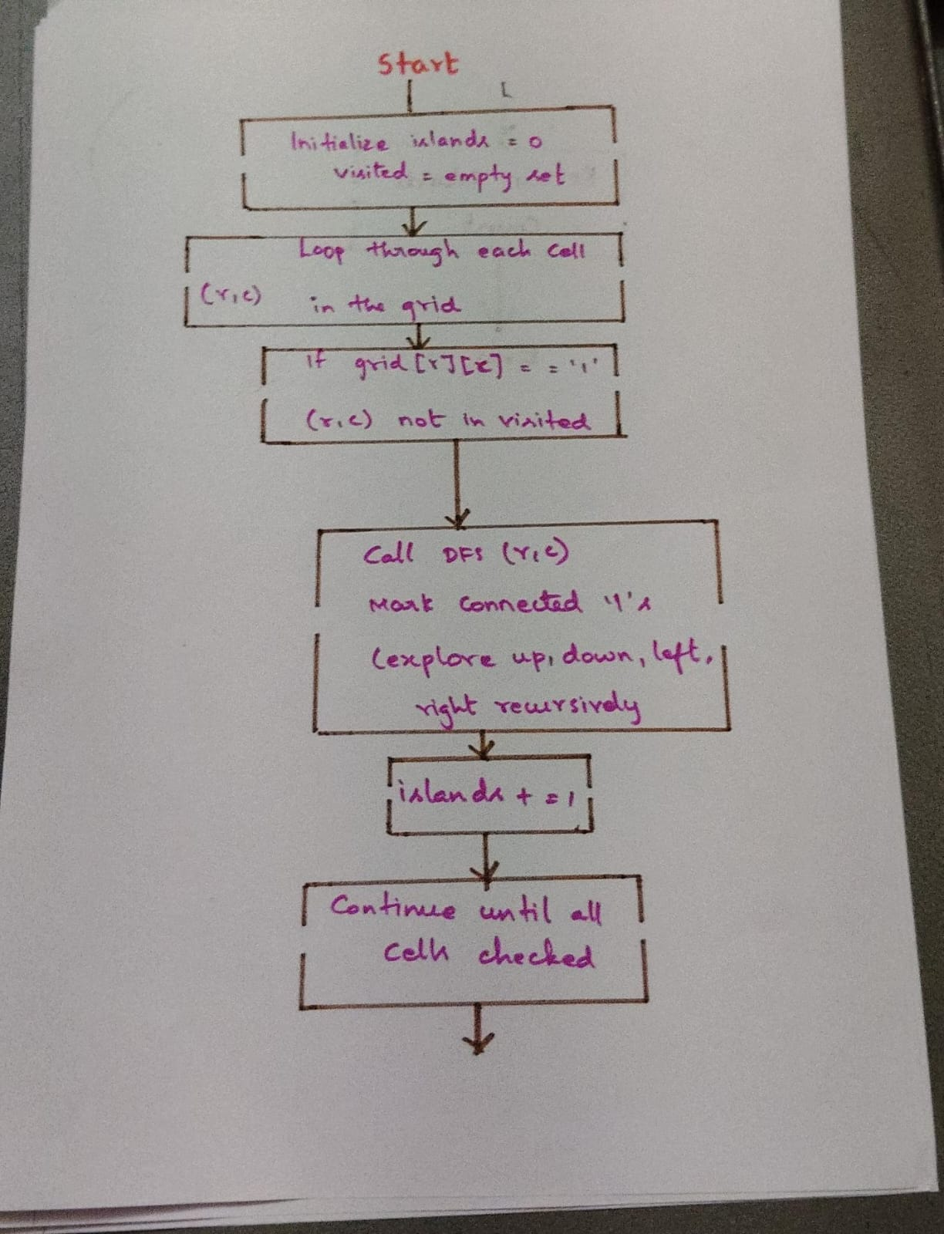
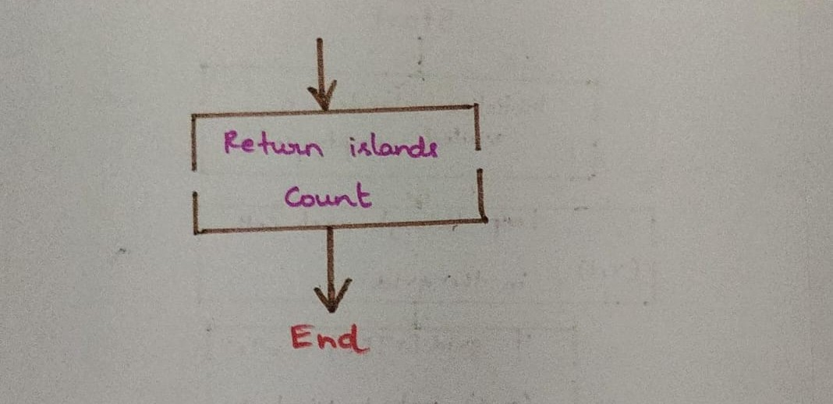 Fig 4.2.1 Traced output
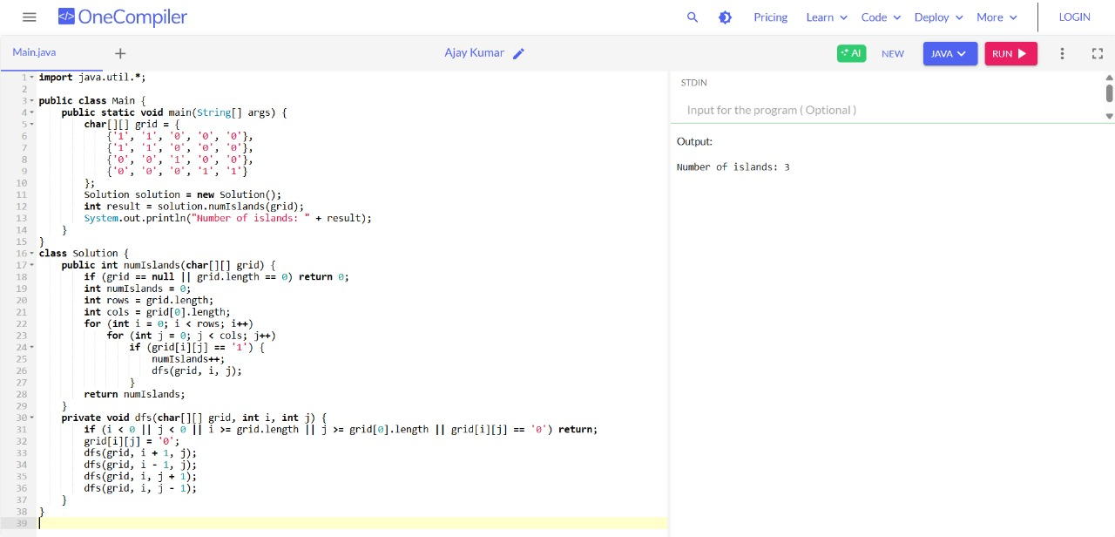
Fig 4.2.2 Compiler Output

